**Installing Additional Arduino Libraries**

Once you are comfortable with the Arduino software and using the built-in functions, you may want to extend the ability of your Arduino with additional libraries.

What are Libraries?

Libraries are a collection of code that makes it easy for you to connect to a sensor, display, module, etc. For example, the built-in LiquidCrystal library makes it easy to talk to character LCD displays. There are hundreds of additional libraries available on the Internet for download. The built-in libraries and some of these additional libraries are [listed in the reference](https://www.arduino.cc/en/Reference/Libraries). To use the additional libraries, you will need to install them.

How to Install a Library

Using the Library Manager

To install a new library into your Arduino IDE you can use the Library Manager (available from IDE version 1.6.2). Open the IDE and click to the "Sketch" menu and then *Include Library > Manage Libraries*.

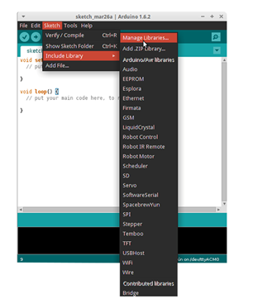

Then the library manager will open and you will find a list of libraries that are already installed or ready for installation. In this example we will install the Bridge library. Scroll the list to find it, then select the version of the library you want to install. Sometimes only one version of the library is available. If the version selection menu does not appear, don't worry: it is normal.

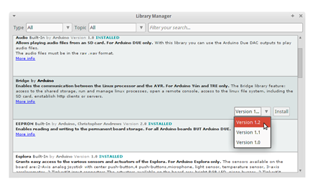

Finally click on install and wait for the IDE to install the new library. Downloading may take time depending on your connection speed. Once it has finished, an *Installed* tag should appear next to the Bridge library. You can close the library manager.

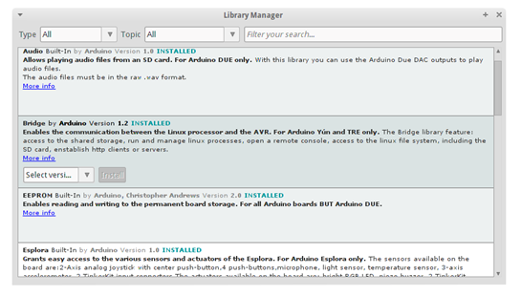

You can now find the new library available in the *Include Library* menu. If you want to add your own library open a new issue on [github](https://github.com/arduino/Arduino/issues).

Importing a .zip Library

Libraries are often distributed as a ZIP file or folder. The name of the folder is the name of the library. Inside the folder will be a .cpp file, a .h file and often a keywords.txt file, examples folder, and other files required by the library. Starting with version 1.0.5, you can install 3rd party libraries in the IDE. Do not unzip the downloaded library, leave it as is.

In the Arduino IDE, navigate to *Sketch > Include Library*. At the top of the drop down list, select the option to "Add .ZIP Library''.

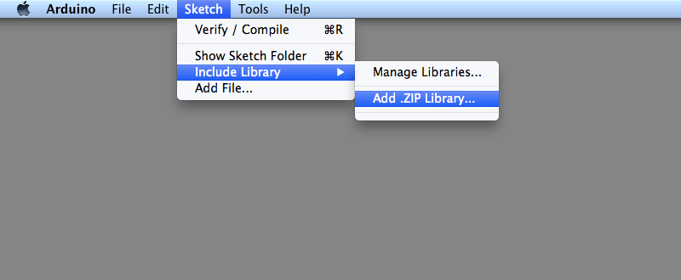

You will be prompted to select the library you would like to add. Navigate to the .zip file's location and open it.

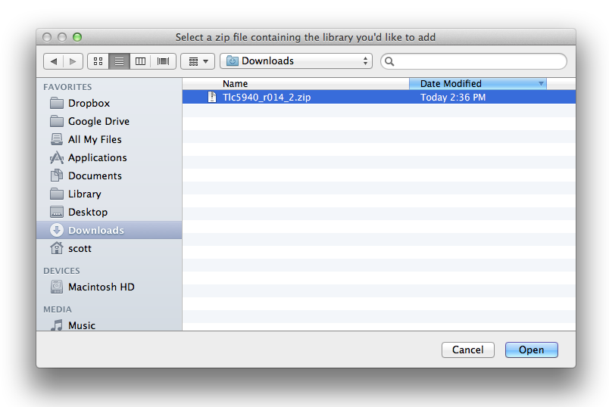

Return to the *Sketch > Import Library* menu. You should now see the library at the bottom of the drop-down menu. It is ready to be used in your sketch. The zip file will have been expanded in the *libraries* folder in your Arduino sketches directory.

NB: the Library will be available to use in sketches, but examples for the library will not be exposed in the *File > Examples*until after the IDE has restarted.

Manual installation

To install the library, first quit the Arduino application. Then uncompress the ZIP file containing the library. For example, if you're installing a library called "ArduinoParty", uncompress ArduinoParty.zip. It should contain a folder calledArduinoParty, with files like ArduinoParty.cpp and ArduinoParty.h inside. (If the .cpp and .h files aren't in a folder, you'll need to create one. In this case, you'd make a folder called "ArduinoParty" and move into it all the files that were in the ZIP file, like ArduinoParty.cpp and ArduinoParty.h.)

Drag the ArduinoParty folder into this folder (your libraries folder). Under Windows, it will likely be called "My Documents\Arduino\libraries". For Mac users, it will likely be called "Documents/Arduino/libraries". On Linux, it will be the "libraries" folder in your sketchbook.

Your Arduino library folder should now look like this (on Windows):

My Documents\Arduino\libraries\ArduinoParty\ArduinoParty.cpp

My Documents\Arduino\libraries\ArduinoParty\ArduinoParty.h

My Documents\Arduino\libraries\ArduinoParty\examples

....

or like this (on Mac and Linux):

Documents/Arduino/libraries/ArduinoParty/ArduinoParty.cpp

Documents/Arduino/libraries/ArduinoParty/ArduinoParty.h

Documents/Arduino/libraries/ArduinoParty/examples

....

There may be more files than just the .cpp and .h files, just make sure they're all there. (The library won't work if you put the .cpp and .h files directly into the libraries folder or if they're nested in an extra folder. For example: Documents\Arduino\libraries\ArduinoParty.cpp and Documents\Arduino\libraries\ArduinoParty\ArduinoParty\ArduinoParty.cpp won't work.)

Restart the Arduino application. Make sure the new library appears in the Sketch->Import Library menu item of the software. That's it! You've installed a library!